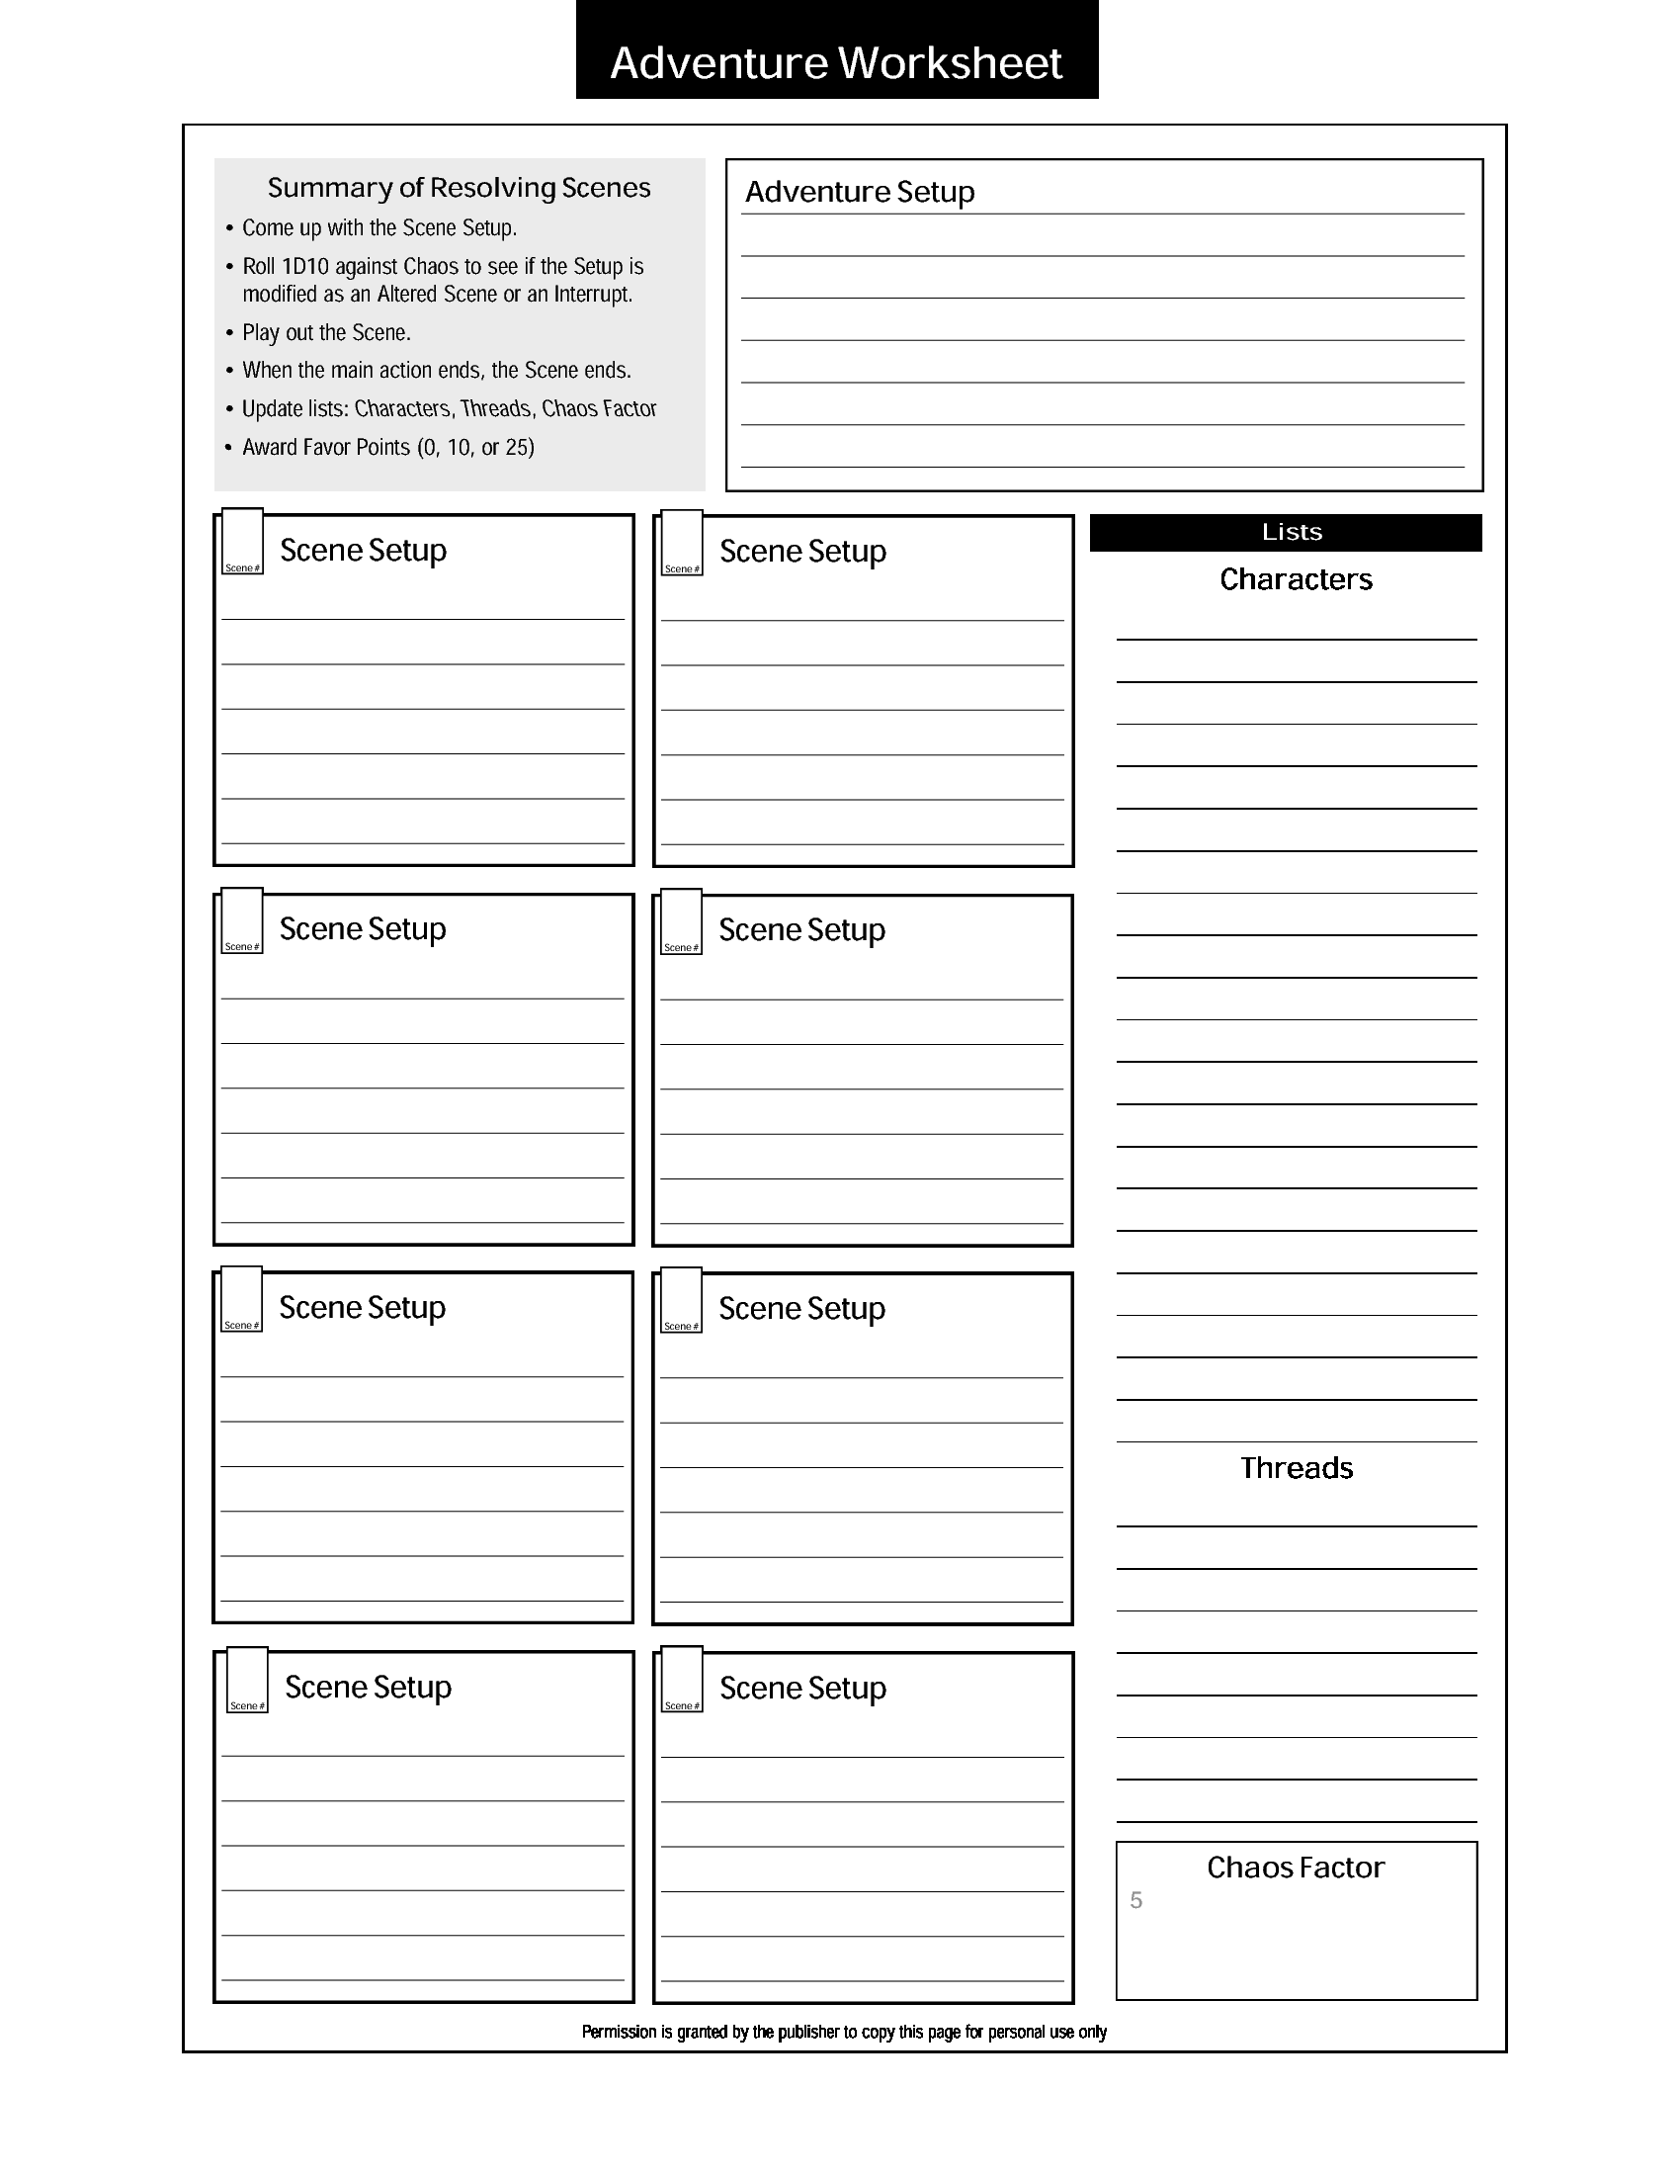

1

2

James is getting ready to leave

James Serrin

work and closes his locker as he

shoulder

hangs his backpack on his left